|  |
| --- |
| **AISC2002 - Data Warehousing and Business Intelligence 01**  Module 5 Application Exercise  Group-F  *Charitha Priya Dongari – 500191110*  *Katterapalli Venkata Satya Narayana Reddy – 500190693*  *Rumana Banu Iliyas Ahmed – 500186725*  *Rohan Bhatt – 500187633*  *Shivam Jolly – 500196452* |

**Exercise 1 –**Explain each method and your research results. Also state the pros and cons with each method and how they are different from each other.

ANSWER 1: -Lets start our journey by explaining about each method and our research done on it.

***INMON***: - Bill Inmon is known as the "Father of Data Warehousing", he had a question to derive all the data into one query or a directory and for that, he had a design methodology of a top-down approach.

Approaches defined for it are as follows: -

Subject oriented - The data in a data warehouse is classified as per the subject area, so it is "specific topic-oriented."

Read Only: - Users will be unable to make changes to the information, which yields the data non-volatile.

Time variant: - The data is stored in time-variant format and is stored for long period.

**PROS AND CONS OF IT: -**

1. It is kind of very much flexible and easy to construct.
2. It is very expensive to build.
3. It is kind of time taking as after making it and deploying it into the project.

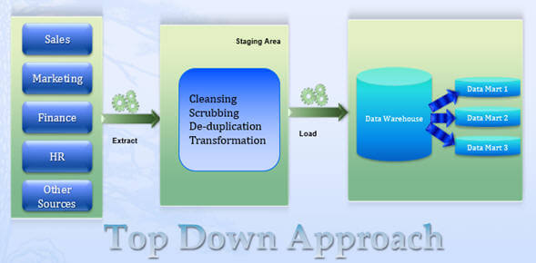

**RALPH KIMBALL: -**

In contrast to Bill Inmon's approach, Ralph Kimball advises establishing a data warehouse from the bottom up. Kimball's philosophy begins with mission-critical data marts that serve divisions' analytic necessities. As per his methodology, data marts are first created to provide reporting and analytical capabilities for specific business\functional processes, and later these data marts can eventually be merged to create a comprehensive enterprise data warehouse. The bottom-up approach focuses on each business process at one point in time so the return on investment could be as quick as the first data mart gets created.

Ralph Kimball's bottom-up approach proposes to create a business matrix that should contain all the common elements (that are used by data marts such as conformed\shared dimension, measures, etc.) defined for the enterprise.

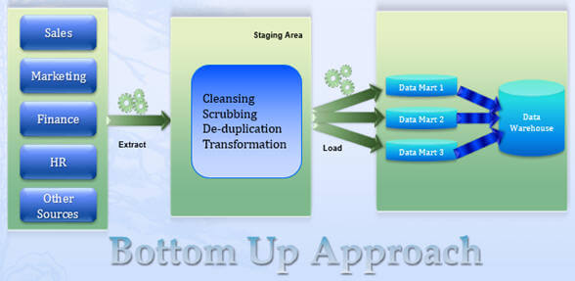

**PROS AND CONS OF IT: -**

1. The bottom-up approach focuses on each business.
2. If not worked carefully one can miss a lot of interconnected information regarding the system.

**COMPARING THE DIFFERENCES: -**

1. Regarding the business decision, the Kimball is tactical whereas the Inmon is strategic.
2. Regarding the structure of data, the Kimball is KPI and scorecards and the Inmon uses multiple varied data.
3. Kimball uses a small number of people whereas Inmon uses a lot of special people in it.
4. Kimball comprises low startup costs and Inmon uses a lot of high accuracies.
5. Kimball, analytic systems can access data directly. While in Inmon’s architecture, analytic systems can only access data in an enterprise data warehouse via data marts.

**Exercise 2 - Then, specify which method suits best the following businesses and why?**

**ANSWER 2: -**

* **Marketing Business : -** According to me the best method suited for this kind of business is Kimball as the marketing business comprises of several smaller business in it that have no relation with each other, so creating a different data and data mart is good for each marketing business as this would also be way cheaper and highly efficient as it would hardly take any time to process the data and deploy it in the market to come up with insights.
* **Banking: -** According to my, the best method for this is nothing but the Inmon as when it comes to banking, the system demands the data that is highly correlated with other branches of the same bank plus the need of high accuracy and mainly no such time constraints regarding any currency.

**REFRENCES: -**

1. <https://www.mssqltips.com/sqlservertip/2976/comparing-data-warehouse-design-methodologies-for-microsoft-sql-server/>
2. https://www.zentut.com/data-warehouse/kimball-and-inmon-data-warehouse-architectures/

|  |  |
| --- | --- |
| Is this my best effort? | ☒ |
| Has the spelling been checked? | ☒ |
| Is the references section correct? | ☒ |
| Is all cited material referenced? | ☒ |
| Are there any materials that you have not cited? (and should therefore be expunged). | ☒ |
| Is the word length OK? | ☒ |
| Have I checked for spelling and grammar? | ☒ |
| Is your name, student number, instructor’s name and course code on the title page? | ☒ |
| Could someone read my introduction and have a rough idea of the body? | ☒ |
| Could someone read my conclusion and know what they would have learn had they read the body? | ☒ |
| Were any of my arguments unsubstantiated or biased? | ☐ |
| Did I leave the essay for a few hours and then read it again from a more objective perspective? | ☒ |
| Did I check the whole checklist? | ☒ |

# Assignment Submission Checklist